ReSearch This Management Pack Guide for Operations Manager 2007 & 2012
Published: April 2013
Version: 6.5.0.7

Copyright
©2010 Cameron Fuller and Pete Zerger, All rights reserved

Terms of Use
All management packs should be thoroughly tested before being introduced into a production Operations Manager environment. The authors of this management pack accept no responsibility or liability for negative impact as a result of use of this management pack in your Operations Manager environment.

Contents
ReSearch This Management Pack Guide 5
Introduction to the ReSearch This Management Pack 6
Supported Configurations 7
Getting Started 8
Before You Import the Management Pack 8
Files in This Management Pack 8
How to import the Management Pack 8
Management Pack for Customizations 8
Security Considerations 8
Low-Privilege Scenario and Run As Profile 8
Understanding Management Pack Operations 8
Console Tasks 9
Console Views 10
Rules 12
Monitors 12
Discoveries 12
Troubleshooting 12
Support 12

ReSearch This Management Pack Guide
The ReSearch This Management Pack is a community repository for information on how to resolve alerts for Operations Manager 2007, System Center Essentials and Microsoft Operations Manager 2005. It also provides a method to search a community repository for alert resolutions and to submit information to share how you have resolved alerts in your environment.
Document Version
This guide was written based on the 6.5.0.8 version of the ReSearch This Management Pack.
Revision History

Release Date | Changes
June 10, 2010 | Original release of this guide  MP version 6.5.0.4
June 25, 2012 | Updated for the new version of Operations Manager and for the new version of ReSearch This.
February 18, 2013 | Updated the search location for the community search in ReSearch This.
April 17, 2013 | Updated the search location for the community search in ReSearch This based on changes to the SCC website.
October 29, 2013 | Updated the search location for the community search in ReSearch This.

Table 1 - Management Pack Versions

Introduction to the ReSearch This Management Pack
ReSearch this was created through contributions from the team at SystemCenterForum and the MVP community members. ReSearch This provides a task which does a lookup based upon the alert information in the SystemCenterForum knowledgebase articles. There are currently over a hundred articles based upon work done by many individuals in the community. The goal of this management pack is to provide an easy to use method for users of OpsMgr, SCE and MOM to be able to share what they have found worked for their environment to resolve the variety of alerts which these products generate.
Features of the ReSearch This Management Pack:
- Task to search the community repository called “ReSearch This”
- Task to submit information to the community repository called “Share This”
- Within a folder called “SystemCenterCentral ReSearch This!” there are a series of views to assist with quickly locating content related to this management pack:
  - “Community Management Pack Catalog”: System Center Central web link for the Community Management Pack Catalog
  - “System Center Central”: System Center Central web link
Getting the Latest Management Pack and Documentation
You can find the ReSearch This Management Pack in the Microsoft Management Pack Catalog. Or on the System Center Central Management Pack Catalog (http://www.systemcentercentral.com/tabid/63/tag/Pack_Catalog+MP_Catalog/Default.aspx).

Supported Configurations
The ReSearch This Management Pack for Operations Manager 2007 supports the following Operations Manager versions:
Operations Manager Version | Notes
System Center Operations Manager 2012
Operations Manager 2007 R2
Operations Manager 2007 SP1
Operations Manager 2007 RTM
System Center Essentials
MOM 2005 SP1 | A MOM 2005 specific version of this management pack exists separately from the OpsMgr versions and is available for download from the System Center Central management pack catalog site referenced in this document.

Table 3 - Management Pack Compatibility

While the Management Pack is compatible with Operations Manager 2007 RTM and SP1, it has only fully been tested against Operations Manager 2007 R2 and Operations Manager 2012.

Getting Started

Before You Import the Management Pack
Before importing the ReSearch This Management Pack, note the following limitations of the management pack:
• The tasks in this management pack are designed to use Internet Explorer which is expected to be in the %programfiles%\internet explorer directory.
- Internet connectivity is required from the Operations Manager Console for the tasks and views in this management pack to function.

Files in This Management Pack
The ReSearch This Management Pack consists of the following files:
• SystemCenterCentralReSearchThis.xml
- ReSearch This MP Guide 6.5.0.7.pdf

How to import the Management Pack
A single XML file is included for this management pack (SystemCenterCentralReSearchThis.xml) which is imported into the Operations Manager Console. For general instructions about importing a management pack, see How to Import a Management Pack in Operations Manager 2007 (http://go.microsoft.com/fwlink/?LinkId=142351).

Management Pack for Customizations
The ReSearch This Management Packs is not sealed so there is no need to create a management pack for customizations.

Security Considerations

Low-Privilege Scenario and Run As Profile
The tasks in this management pack are executed on the console as the user who is logged into the console. Therefore the ReSearch This Management Pack does not use Run As accounts to perform its actions.

Understanding Management Pack Operations
The ReSearch This Management pack contains two Console Tasks and five console views which are detailed within this section.

Console Tasks
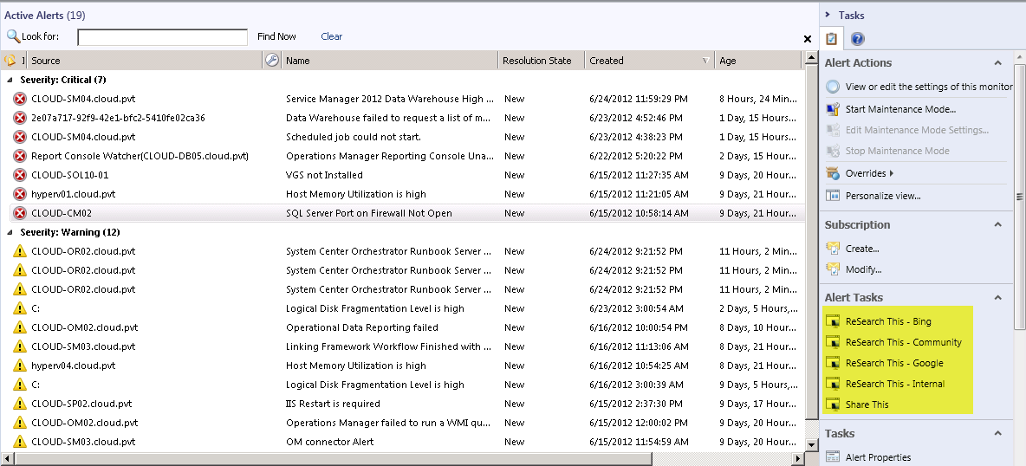
Figure 1 - Monitoring Console Task for ReSearch This
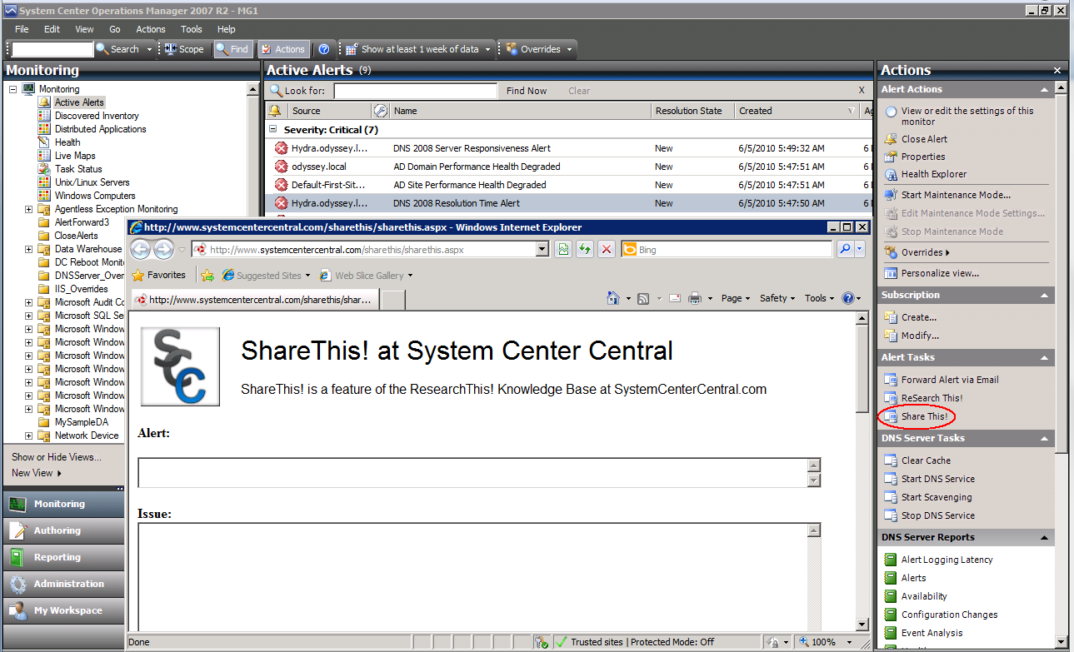
Figure 2 - Monitoring Console Task for Share This
The following table lists the tasks defined for this management pack.
Task Name | Command Line | Parameters | Additional Settings
ReSearch This – Bing | "%programfiles%\internet explorer\iexplore.exe" | http://www.bing.com/search?q=$Name$ | No working directory  Display output when this task is run: unchecked
ReSearch This – Community | "%programfiles%\internet explorer\iexplore.exe" | http://www.systemcentercentral.com/search-results/?search=$Name$ | No working directory  Display output when this task is run: unchecked
ReSearch This – Google | "%programfiles%\internet explorer\iexplore.exe" | http://www.google.com/#hl=en&sclient=psy-ab&q=$Name$ | No working directory  Display output when this task is run: unchecked
ReSearch This – Internal | "%programfiles%\internet explorer\iexplore.exe" | http://OpsMgrKB/_layouts/OSSSearchResults.aspx?k=$Name$ | No working directory  Display output when this task is run: unchecked
Share This | Http://www.systemcentercentral.com/sharethis/sharethis.aspx | Http://www.systemcentercentral.com/sharethis/sharethis.aspx | No working directory  Display output when this task is run: unchecked

Table 3 – Tasks and Configurations

Console Views
The ReSearch This management pack includes a top level folder and two different URL views as shown below
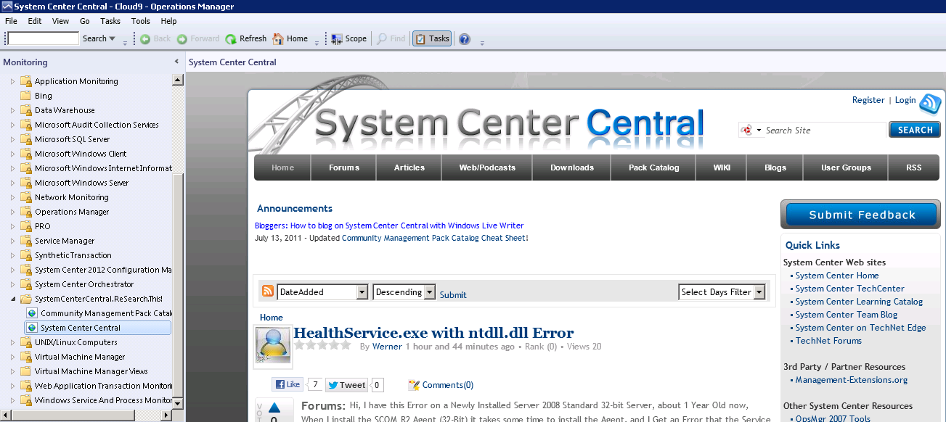
Figure 3 – Monitoring Console View
The following table lists the predefined views that are included in the ReSearch This Management Pack:
Console View Name | Console View Folder | Description
Community Management Pack Catalog | SystemCenterCentral ReSearch This! | System Center Central web link for the Community Management Pack Catalog
System Center Central | SystemCenterCentral ReSearch This! | System Center Central web link

Table 4 – Console Views

Rules
There are no rules in this management pack.

Monitors
There are no monitors in this management pack.

Discoveries
There are no discoveries in this management pack.

Troubleshooting
The ReSearch This management pack has been designed to provide a simple integration path to a community knowledge repository. This management pack has been created as an unsigned management pack so that it can easily be adapted to requirements of your environment. Since this is an unsealed management pack common issues can often easily be resolved by changing the management pack in the Operations Manager Console or the Authoring Console.
Incorrect path to the web browser:
The ReSearch This management pack defaults the location of iexplore.exe to “%programfiles%\internet explorer”. To change this default, alter the ReSearch This! And Share This! Tasks to the appropriate path for iexplore.exe in your environment.

Alternate browsers:
While ReSearch This has not been tested with browsers other than Internet Explorer, the ReSearch This! and Share This! Tasks could also be altered to run a different program instead of %programfiles%\internet explorer\iexplore.exe.
Configuring Internal search:
The task for the internal URL will need to be customized to reflect the correct location to search internally. To identify this URL, go to the internal search site and search on the word test. Copy the URL which results up to the point where the word “test” occurs in the URL. In the authoring pane edit the “ReSearch This – Internal” task command line parameters to reflect this search.
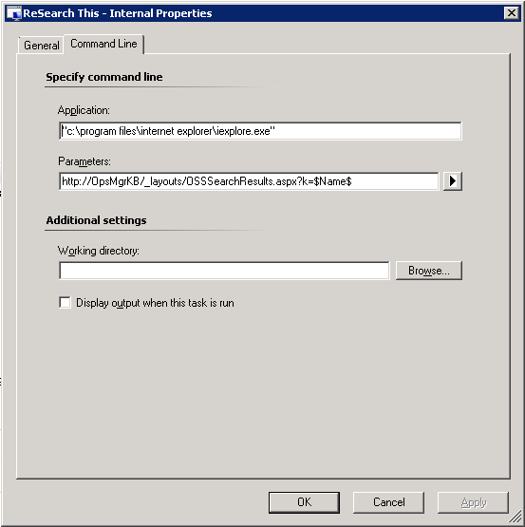
Figure 4 – Configuring the Internal search

Support
The ReSearch This management pack has a forum for support is available at www.systemcentercentral.com.

